***Beneficiary sheet***

**Name of the project:** Computer Network for Exclusive Residence

**Project location:** Municipality Iasi, Iasi County, Street Petre Andrei

**Project beneficiary:** PEG CONSTRUCT

**Entity in charge with project implementation:** SC -DLCN- SRL

**Project objectives:** The objective is designing, implementing and administering the computer networks in the residential complex Exclusive Residence.

**Target areas and/or groups aimed:**

The target group addressed by the implementation of this project is represented by the inhabitants of the complex, agencies or

companies operating in the compound, staff members of the residential units.

**Project justification:**

Implementing a computer network for the entire complex will benefit by cutting back on costs and allowing for efficient use of resources, access of data from any device.

**Time interval:**

*Start date of the project*:28.03.2020

*Date of project completion*: …

**Estimated total cost of the project: ….**

The project fulfills all the specified conditions mentioned in the applicant’s guide, as required (coverage area, population, minimum value), etc.

The project complies with the legislation and within the established time interval we guarantee fulfillment of the task with utmost benefits for the recipient.

The complex Exlcusive Residence is located in Iasi county on Petre Andrei Street and incorporates 5 apartment blocks (C1, C2, C3, C4, C5) with underground and above-ground parking, a security block, an administrative office, 5 commercial premises, leisure areas.

Each block has 5 floors and contains 20 flats as follows: 6 1-room flats, 7 2-room flats, 7 3-room flats.

There are allocated 63 parking spots out of 100, of which 40 for underground parking and 23 for over ground parking area.

The security block is located at its entrance of the complex. It is a single level building with one room.

The administrative office composed of 3 rooms is located on the ground floor of block C3.

Commercial spaces occupy the ground floor of the buildings C4 and C5, which include a supermarket, a restaurant, a pharmacy, a coffee shop and a hair salon.

The recreation areas are represented by a playground for children in the center of the complex, a pools and a spas on the 5th floor of the buildings C1 and C3.

In the current year, 2020, 142 people live in the complex. The staff of the complex consists of 2 administrators, 1 secretary, 4 security guards, 5 cleaning ladies.

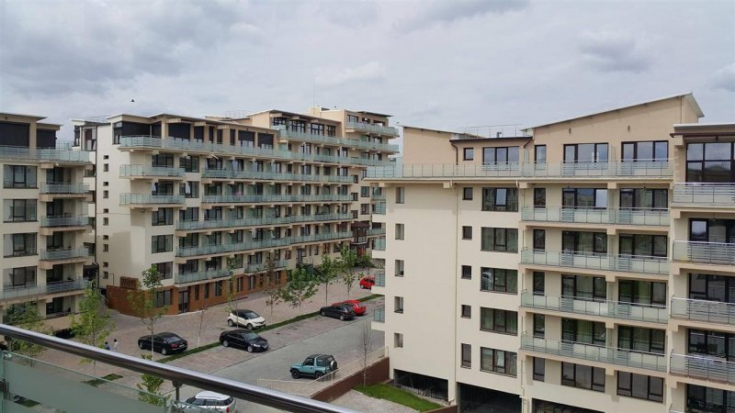

Exclusive Residance Layout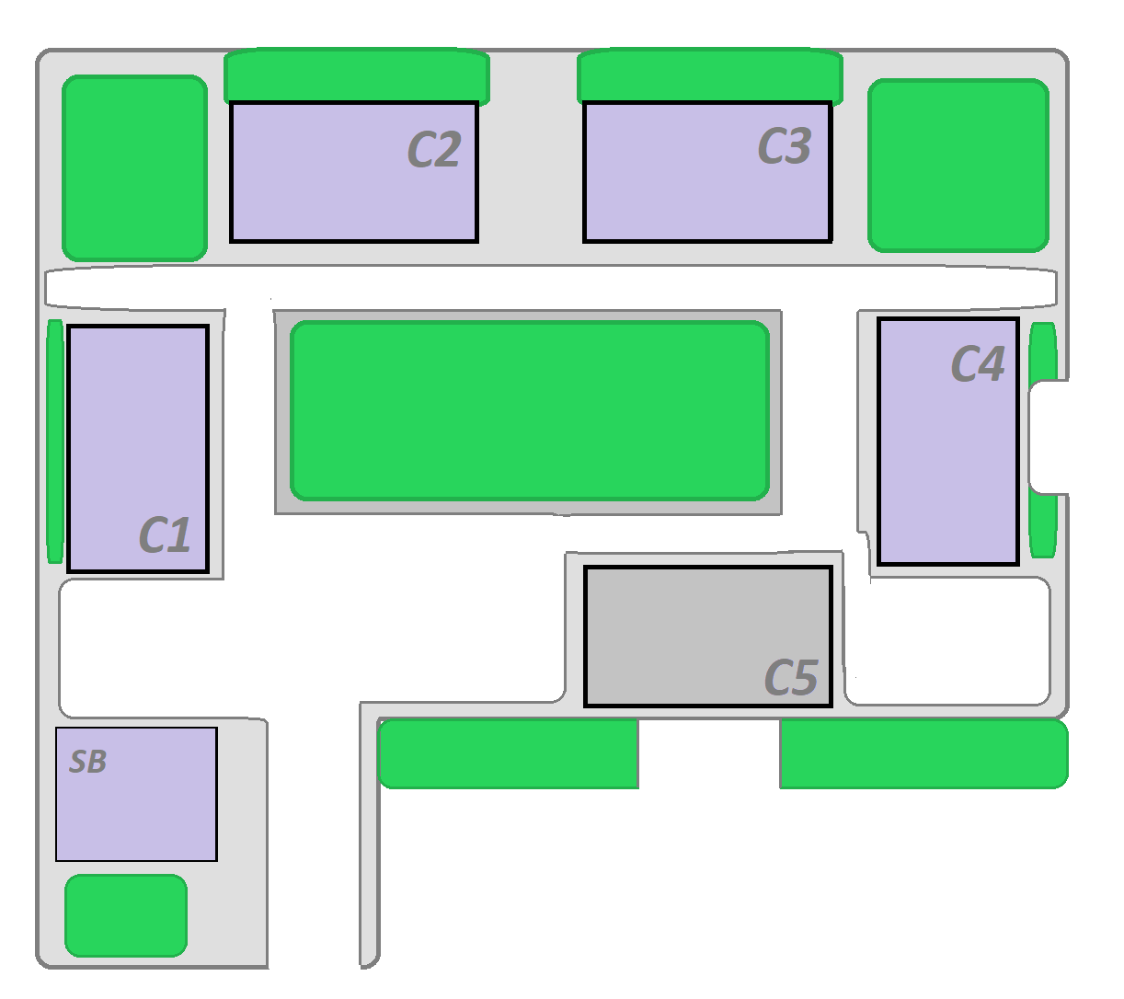

Flat with 1 room: 32 m2

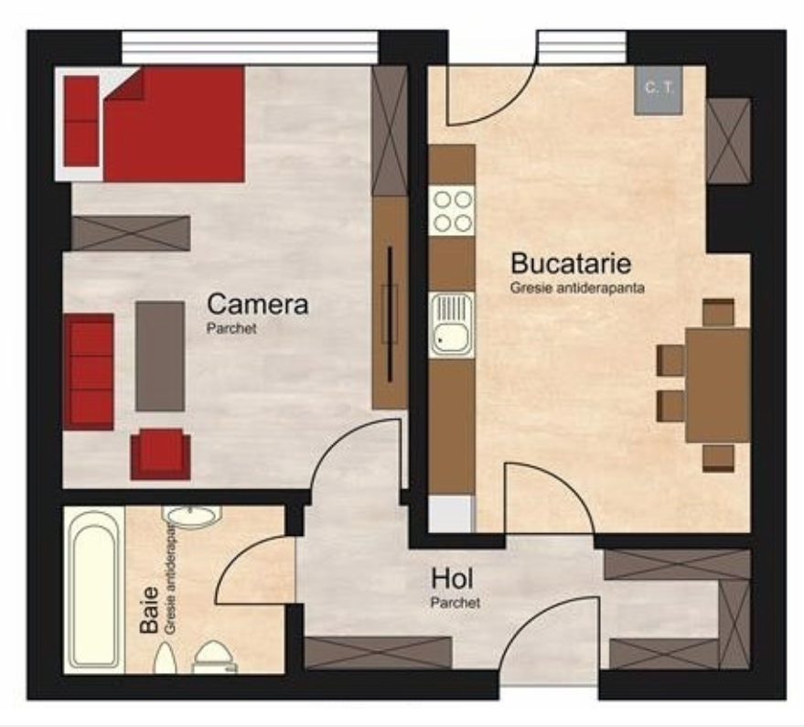

Flat with 2 rooms: 40 m2

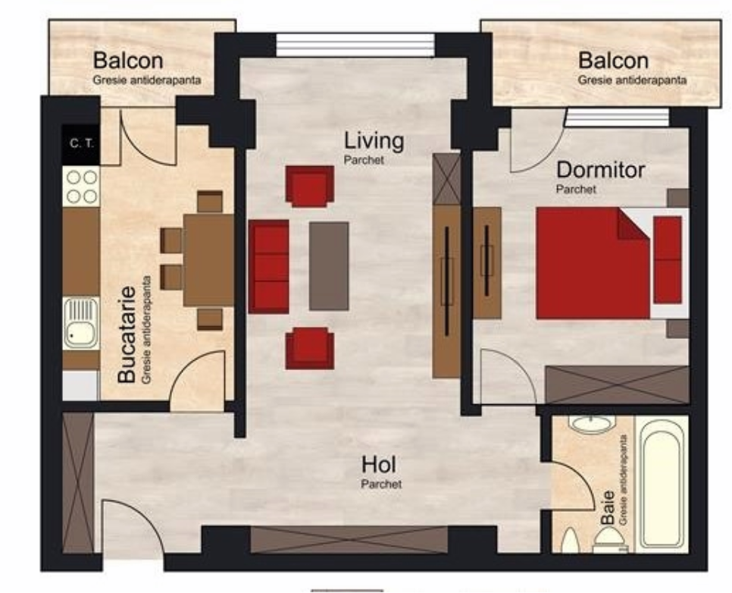

Flat with 3 rooms: 67 m2

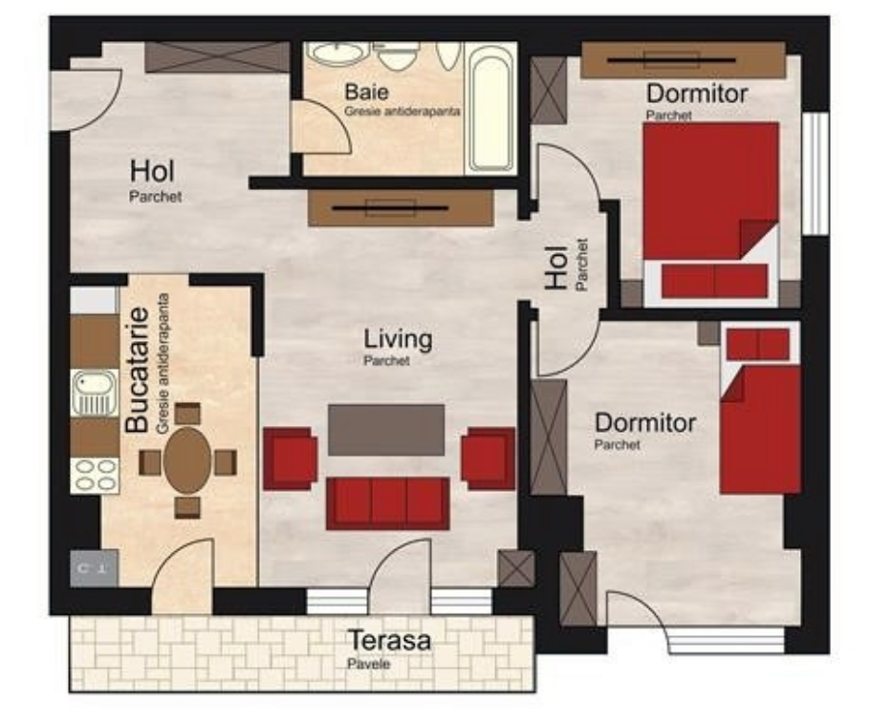

Security block: 35.39 m2

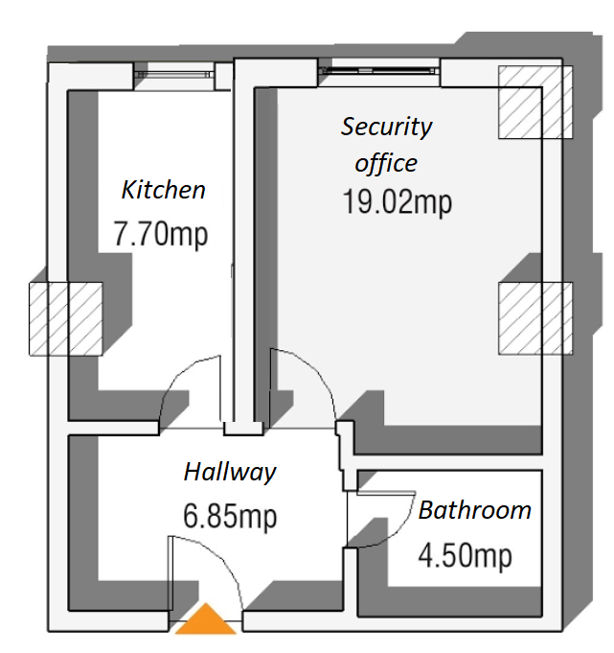

Administrative block: 67 m2

